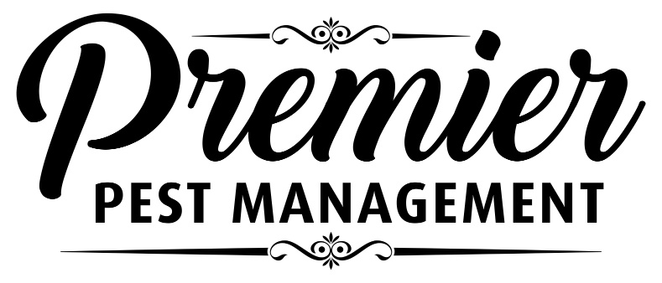
CLIENT PREPARATION FORM
IMPORTANT NOTICE TO RESIDENTS

Premier Pest Management Ltd. will be providing a MOUSE TRAPPING SERVICE on:

Please provide access to your unit! If you cannot be home, please leave keys with a neighbor or council representative. People and pets do not need to vacate.
TO ENSURE SUCCESS, THE FOLLOWING PREPARATIONS MUST BE DONE
• Remove enough items from kitchen and bathroom cupboards below the sinks to allow us to access the back of the cabinet.
• Clean, clean clean! All kitchen and bathroom surfaces must be clean and grease free, especially those areas around the fridge, stove, microwave and toaster.
• Reduce clutter! Mice hide in cluttered areas, and they use paper to build nests. Ensure the area next to the outside walls and the garage, crawlspace, attic, storage areas, are neat and tidy.
• Throw out garbage daily and ensure dirty dishes are not left out overnight.
• Ensure pet food is secured in sealed heavy duty plastic containers, and is not left out after the pets have fed.
• Remove bird feeders from decks or back yards, and clean up all spilled seed.
After our treatment is complete all contents may be put back in the cupboards. Holes around plumbing and heating pipes should be closed with steel wool after the mice have been eliminated. Exterior entry points and gaps under outside doors should be closed immediately.
We will be following up to check traps until the problem is solved.
We will be placing a variety of snap traps, glue traps and mechanical traps.
Please do not disturb them!
Protecting Your Home Your Family Your Business

