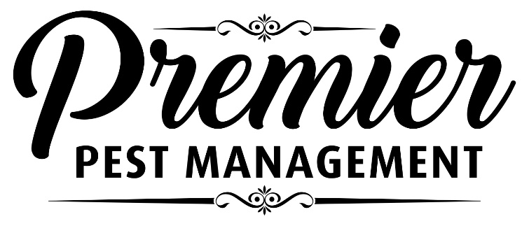
CLIENT PREPARATION FORM

IMPORTANT NOTICE TO RESIDENTS
Premier Pest Management Ltd. will be providing a RAT TRAPPING SERVICE in your residence on:
_______________, at _____ a.m./p.m.

People and pets do not need to vacate.
TO ENSURE SUCCESS THE FOLLOWING PREPARATIONS MUST BE DONE
• Remove enough items from kitchen and bathroom cupboards below the sinks to allow us to access the back of the cabinet.
• Clean, clean clean! All kitchen and bathroom surfaces must be clean and grease free, especially those areas around the fridge, stove, microwave and toaster.
• Reduce clutter! Inside the house as well as in the shed, garage, attic, and crawlspace. Cut vegetation 3 feet away from the outside of the house and stack lumber or firewood 18 inches away from the outside walls, 6 inches off the ground. Rats hide in cluttered, sheltered areas and they use paper to build nests.
• Throw out garbage daily and ensure dirty dishes are not left out overnight.
• Ensure outside garbage and compost containers are rodent proof.
• Ensure pet food is secured in sealed heavy duty containers, and is not left out after the pets have finished eating.
• Remove bird feeders from decks or back yards, and clean up all spilled seed.
• Fix dripping taps or leaking pipes, and ensure splashed water does not remain in the kitchen or bathroom.
Exterior entry holes and holes around plumbing and heating pipes on the interior should be done as soon as possible.
It may take several visits over two to three weeks for complete elimination.
We will be placing a variety of snap and/or glue traps.
Please do not touch the traps.
Protecting Your Home Your Family Your Business

