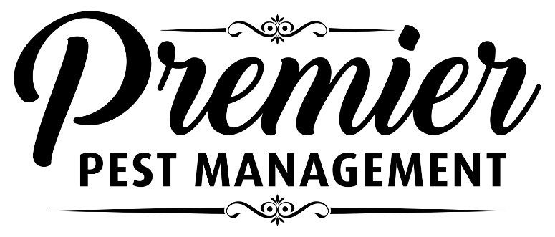
CLIENT PREPARATION FORM

IMPORTANT NOTICE TO RESIDENTS
Premier Pest Management. will be providing a FLEA CONTROL SERVICE in your residence on
__________________, at _________a.m./p.m.
All people and pets must vacate treated units for a minimum of FOUR (4) to SIX (6) hours after the treatment. You must leave upon commencement of the work. Pregnant or nursing women, children under two (2) years old, or those with allergies or respiratory problems, must vacate for EIGHT (8) to TWELVE (12) HOURS OR OVERNIGHT. Aquariums must be covered and filters turned off.

TO ENSURE SUCCESS THE FOLLOWING PREPARATIONS MUST BE DONE PRIOR TO OUR ARRIVAL
• Remove all small items from the floors, especially in closets, under beds, behind couches, etc.
• Move everything 6 inches away from the baseboard area. Electronic equipment and heavy furniture may be left in place.
• Thoroughly vacuum all carpets and floors. Couches, chairs or other areas pets frequent should be vacuumed as well. Consider steam cleaning heavily soiled furniture or carpets.
• Pet bedding must be laundered on hot settings.
• Pets must be treated with a flea control measure as well.
Upon returning home please ventilate your unit and replace all contents, but do not wash baseboard areas for two weeks. Do not steam clean carpets for 30 days.
Please vacuum daily for the first week after treatment. This stimulates fleas to emerge from the pupal stage and contact the treated areas.
You may experience activity for up to three weeks after the treatment. If activity continues after this time, you may need a follow-up treatment.
Avoid touching treated areas.
Protecting Your Home Your Family Your Business

